# MAHENDRA INSTITUTE OF TECHNOLOGY

**Department of Computer Science and Engineering**

**IBM NALAIYA THIRAN**

**Smart Farmer-IOT Enabled Smart Farming Application**

|  |  |
| --- | --- |
| **TITLE** | Smart Farmer-IOT Enabled Smart Farming Application |
| **DOMAIN NAME** | Internet of things |
| **LEADER NAME** | KOWSALYA D |
| **TEAM MEMBERS** | KAMALAKANNAN R  KARTHICK S  NITHEEN V P |

# PROBLEM STATEMENT :

To incorporate the process of working and also elevate the smart farming using IOT enabled smart Farmer technique since the traditional Farmer technique very complex one.

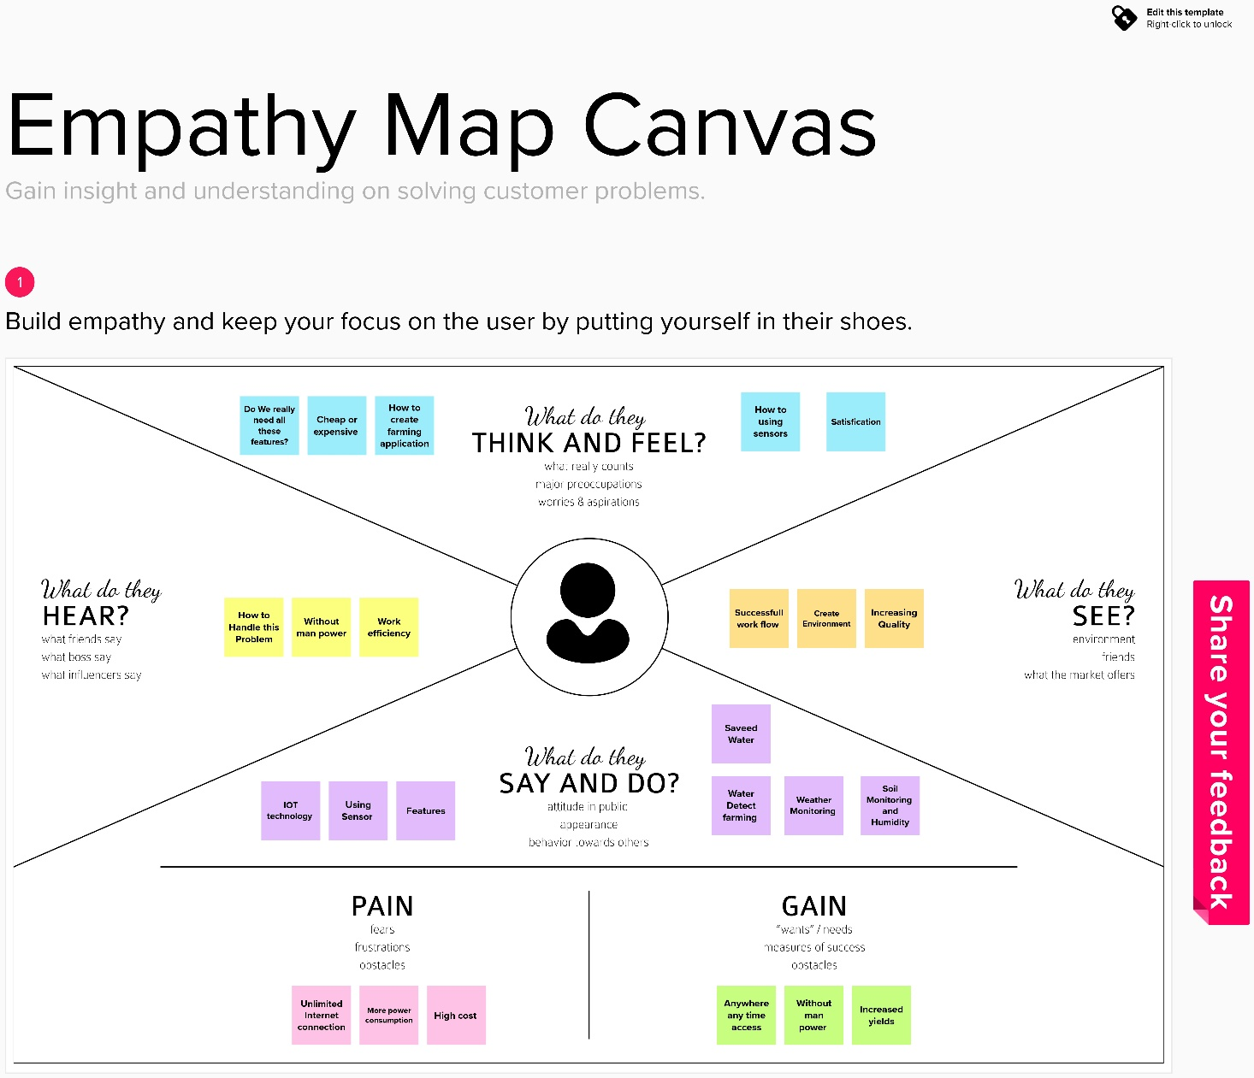**Empathy Map Canvas:**